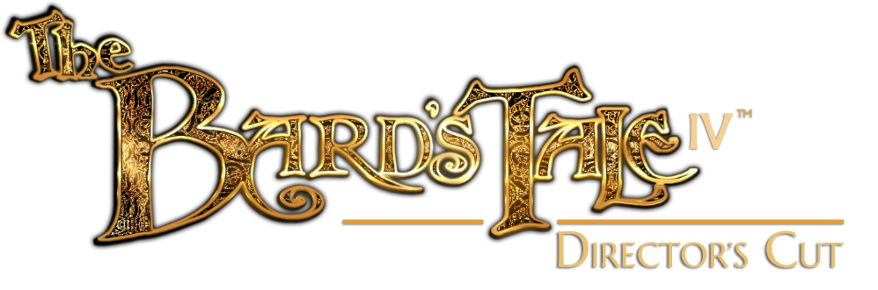

Company: inXile Entertainment / Koch Media
Platforms: Playstation 4, XBox One
Genre: Fantasy RPG, Tactical RPG, Dungeon Crawler, Sequel

The Bard's Tale IV: Director’s Cut is the triumphant return of one of the most iconic RPG series of all-time. Return to Skara Brae and explore the wider world of Caith in a heroic adventure featuring 50+ hours of gameplay, 350 speaking parts, a Legacy Mode for returning fans, and over 100 pieces of award-nominated music!
- Create the Hero You Want To Be: Play as Bard, Fighter, Practitioner, and Rogue, each featuring 60-70 skills and collectively unlocking 21 unique classes.
- Craft your Party, Your Way: Start with a single character, recruiting or creating new heroes to bolster your ranks. Build a party that suits your play style!
- Outsmart Evil: Battle enemies in dynamic, intuitive turn-based tactical combat that rewards clever thinking, superior strategies, and decisive positioning.
- Unlock the Secrets of the Past: Unravel challenging mysteries. If your enemies don’t get you, the devious riddles and dangerous traps just might.
- Elven Puzzle Weapons: Discovery and mystery come in many forms. Gain ancient Elven weapons whose secrets you’ll need to uncover by carefully examining them.
- Definitive Edition: The Director’s Cut brings more character customization options, new items, new enemies revised UI, and a free expansion dungeon.
- New Song of Exploration “Strugglers’ Lament”: Whether you just want to explore and fight or if you get stuck, simply play this song to skip mandatory puzzles.
- Controller support co-developed by inXile and Xbox Game Studios for optimal player control.
The Bard's Tale IV: Director’s Cut is built to scratch that classic RPG dungeon crawler itch with the use of modern design principles and top of the line graphics, breathing life into this famous series for fans old and new. While there are plenty of callbacks for returning players, no prior experience with the series is necessary. The Bard’s Tale IV: Director’s Cut is designed for RPG fans of all stripes to enjoy.
Supported Languages: VO & Subtitles (English), Subtitles only (French, German, Polish, Russian, Spanish)
ESRB Rating: T
Website: http://www.bardstale.com

